Autorabbit, HCL and Capgemini Devops Interview Questions
on October 04, 2018

Here is the List of DevOps Interview questions of my old Student
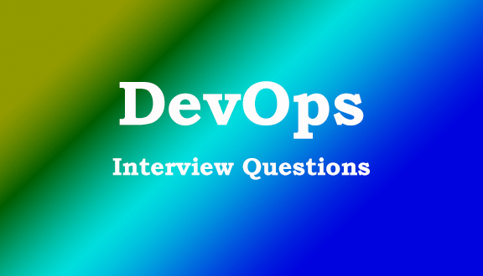

Auto Rabbit Interview Questions:

1.How do you increase RAM for a EC2 instance?

2. How do you maintain DR in a cloud?

3. How do you configure SSL in Tomcat?

Capgemini Interview Questions:
1.what is chef work flow
2.how we get the properites of node
3.what is resourse
4.what is diff b/w chef server and chef client
5.what is run list
6.what is diff b/w cookbook and recipe
7.how bootstrap will work & what is process
8.which language chef deploy

HCL Interview Questions:
1) tell me your roles and responsabilites ?
2) what is python- boto ?
3) are you using private cloud ?
4) how to create the aws instances using configuration tools ?
5) asking on modules ?
6) ci/cd work flow ?
7) asking about plugins in jenkins ?
8) explain ansible playbook ?
9) how to deploy the artifacts ?
10) how to build the artifacts ?
11) git fetch ?
12) git pull ?

